Class Activity – 1
Scenario 1: Student Academic Performance Dashboard
R program:
library(ggplot2)
student <- data.frame(
StudentID = 1:10,
Attendance = c(85,90,78,95,88,70,80,92,75,89),
Marks = c(80,92,70,95,85,60,75,94,68,88),
Department = c("CSE","AI","IT","ECE","CSE","AI","IT","ECE","CSE","AI")
)
ggplot(student, aes(x=Attendance, y=Marks, color=Department)) +
geom_point(size=4) +
labs(title="Student Academic Performance",
x="Attendance (%)",
y="Internal Marks",
color="Department") +
theme_minimal()
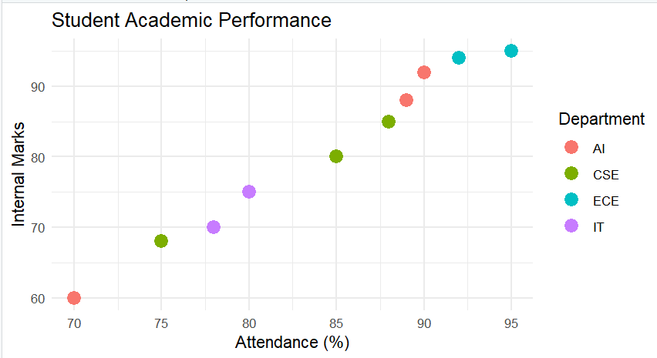

Python Program:
import pandas as pd
import matplotlib.pyplot as plt
import seaborn as sns

student = pd.DataFrame({
"StudentID":[1,2,3,4,5,6,7,8,9,10],
"Attendance":[85,90,78,95,88,70,80,92,75,89],
"Marks":[80,92,70,95,85,60,75,94,68,88],
"Department":["CSE","AI","IT","ECE","CSE","AI","IT","ECE","CSE","AI"]
})

plt.figure(figsize=(8,6))
sns.scatterplot(data=student,
x="Attendance",
y="Marks",
hue="Department",
s=100)

plt.title("Student Academic Performance Dashboard")
plt.xlabel("Attendance (%)")
plt.ylabel("Internal Marks")
plt.legend(title="Department")
plt.show()
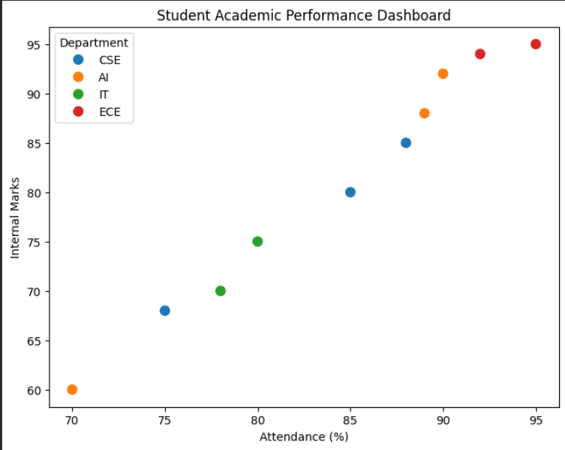

Scenario 2: Electric Vehicle Market Analysis
R program:
library(ggplot2)
ev <- data.frame(
Model=c("A","B","C","D","E","F"),
Battery=c(40,50,60,75,90,100),
Price=c(12,15,20,28,35,40),
Range=c(250,320,380,450,520,600),
Manufacturer=c("Tesla","BYD","Tata","Tesla","BYD","Tata")
)
ggplot(ev, aes(x=Battery,
y=Price,
size=Range,
color=Manufacturer)) +
geom_point(alpha=0.8) +
labs(title="EV Battery Capacity vs Price",
x="Battery Capacity (kWh)",
y="Price (Lakhs)") +
theme_minimal()
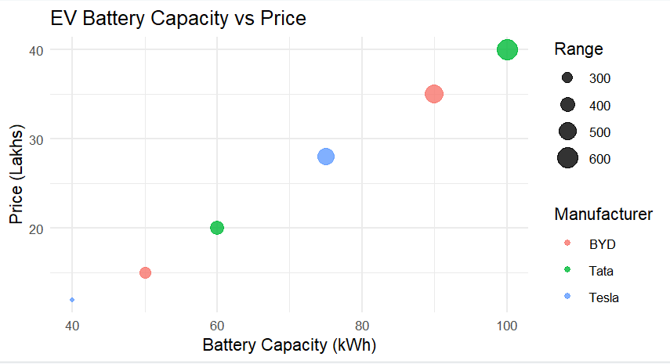
Python Program:
import pandas as pd
import matplotlib.pyplot as plt
import seaborn as sns

ev = pd.DataFrame({
"Model":["A","B","C","D","E","F"],
"Battery":[40,50,60,75,90,100],
"Price":[12,15,20,28,35,40],
"Range":[250,320,380,450,520,600],
"Manufacturer":["Tesla","BYD","Tata","Tesla","BYD","Tata"]
})

plt.figure(figsize=(8,6))
sns.scatterplot(data=ev,
x="Battery",
y="Price",
hue="Manufacturer",
size="Range",
sizes=(100,600))

plt.title("Electric Vehicle Market Analysis")
plt.xlabel("Battery Capacity (kWh)")
plt.ylabel("Price (Lakhs)")
plt.show()
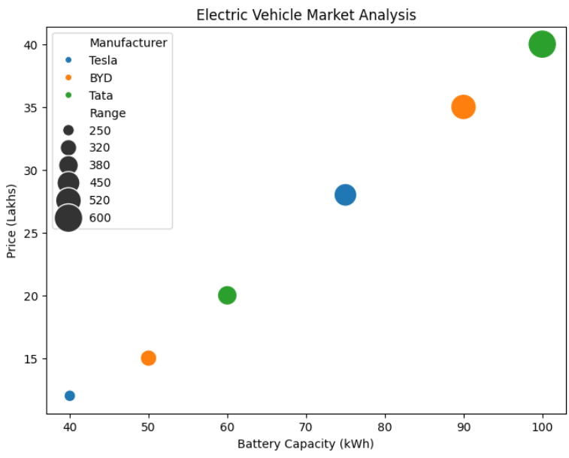

Scenario 3: Hospital Patient Admission Analysis
R program:
library(ggplot2)
hospital <- data.frame(
Department=c("Cardiology","Neurology","Orthopedics","Pediatrics"),
Patients=c(150,120,180,160),
Cost=c(50000,65000,45000,30000)
)
ggplot(hospital,
aes(x=Department,
y=Patients,
fill=Department)) +
geom_bar(stat="identity") +
geom_text(aes(label=Cost),
vjust=-0.5,
size=5) +
labs(title="Hospital Patient Admissions",
y="Number of Patients") +
theme_minimal()
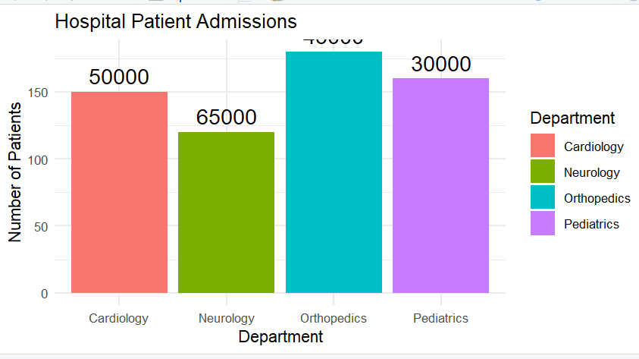

Python Program:
import pandas as pd
import matplotlib.pyplot as plt

hospital = pd.DataFrame({
"Department":["Cardiology","Neurology","Orthopedics","Pediatrics"],
"Patients":[150,120,180,160],
"Cost":[50000,65000,45000,30000]
})

plt.figure(figsize=(8,6))

bars = plt.bar(hospital["Department"],
hospital["Patients"],
color=["red","blue","green","orange"])

for i, bar in enumerate(bars):
plt.text(bar.get_x()+bar.get_width()/2,
bar.get_height()+2,
hospital["Cost"][i],
ha='center')

plt.title("Hospital Patient Admissions")
plt.xlabel("Department")
plt.ylabel("Number of Patients")
plt.show()

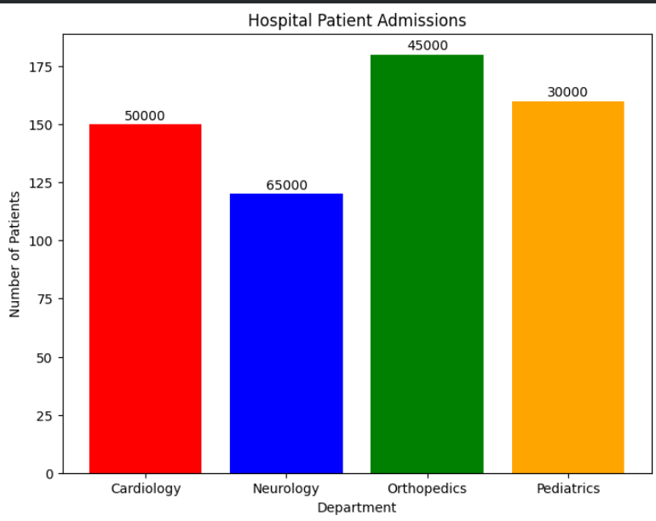

Scenario 4: Weather Monitoring System
R program:
library(ggplot2)
weather <- data.frame(
Date=rep(1:10,3),
Temperature=c(30,31,32,33,32,31,30,29,30,31,
28,29,30,31,32,33,34,33,32,31,
25,26,27,28,29,30,29,28,27,26),
City=rep(c("Chennai","Delhi","Bangalore"),each=10)
)

ggplot(weather,
aes(x=Date,
y=Temperature,
color=City,
linetype=City)) +
geom_line(size=1.2) +
labs(title="Temperature Trend",
x="Day",
y="Temperature (°C)") +
theme_minimal()
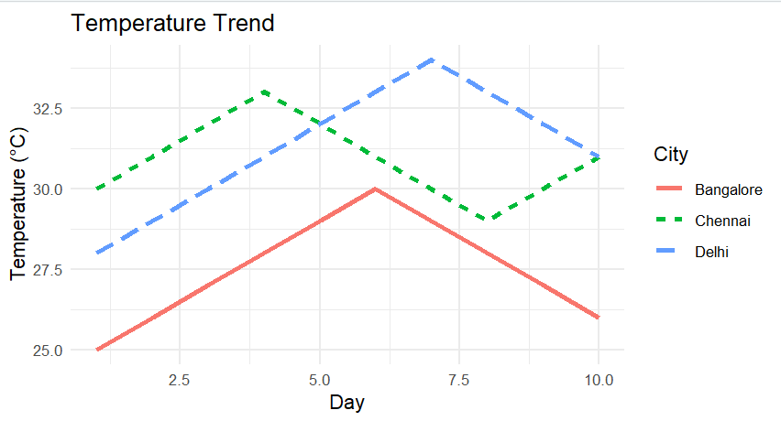
Python Program:
import pandas as pd
import matplotlib.pyplot as plt

weather = pd.DataFrame({
"Date":list(range(1,11))*3,
"Temperature":[30,31,32,33,32,31,30,29,30,31,
28,29,30,31,32,33,34,33,32,31,
25,26,27,28,29,30,29,28,27,26],
"City":["Chennai"]*10 + ["Delhi"]*10 + ["Bangalore"]*10
})

plt.figure(figsize=(8,6))

styles = {
"Chennai":"-",
"Delhi":"--",
"Bangalore":":"
}

for city in weather["City"].unique():
data = weather[weather["City"]==city]
plt.plot(data["Date"],
data["Temperature"],
linestyle=styles[city],
linewidth=2,
label=city)

plt.title("Temperature Trend")
plt.xlabel("Day")
plt.ylabel("Temperature (°C)")
plt.legend()
plt.show()
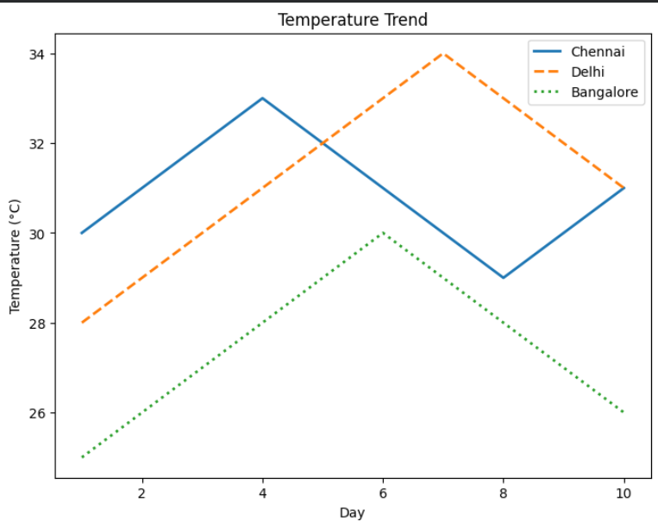

Scenario 5: Supermarket Sales Analysis
R program:
library(ggplot2)
sales <- data.frame(
Month=rep("January",9),
Category=rep(c("Food","Drinks","Snacks"),3),
Sales=c(120,90,80,
140,100,95,
130,85,100),
Branch=rep(c("A","B","C"),each=3)
)

ggplot(sales,
aes(x=Category,
y=Sales,
fill=Branch)) +
geom_bar(stat="identity",
position="dodge") +
labs(title="Monthly Sales by Branch") +
theme_minimal()
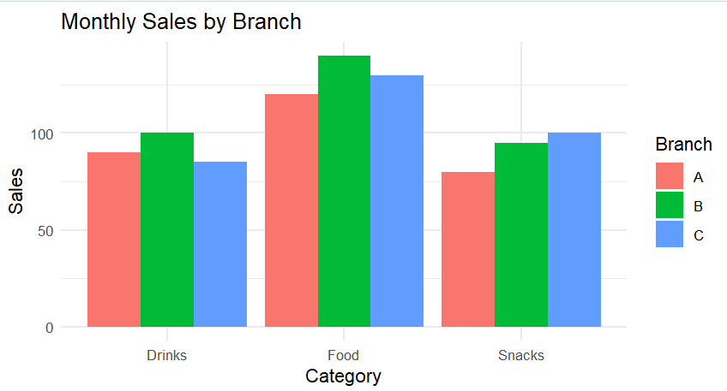
Python Program:
import pandas as pd
import matplotlib.pyplot as plt
import numpy as np

sales = pd.DataFrame({
"Category":["Food","Drinks","Snacks"]*3,
"Sales":[120,90,80,
140,100,95,
130,85,100],
"Branch":["A"]*3 + ["B"]*3 + ["C"]*3
})

categories = ["Food","Drinks","Snacks"]
branches = ["A","B","C"]

x = np.arange(len(categories))
width = 0.25

plt.figure(figsize=(8,6))

for i, branch in enumerate(branches):
values = sales[sales["Branch"]==branch]["Sales"]
plt.bar(x+i*width,
values,
width,
label=branch)

plt.xticks(x+width,categories)
plt.title("Monthly Sales by Branch")
plt.xlabel("Product Category")
plt.ylabel("Sales Amount")
plt.legend(title="Branch")
plt.show()
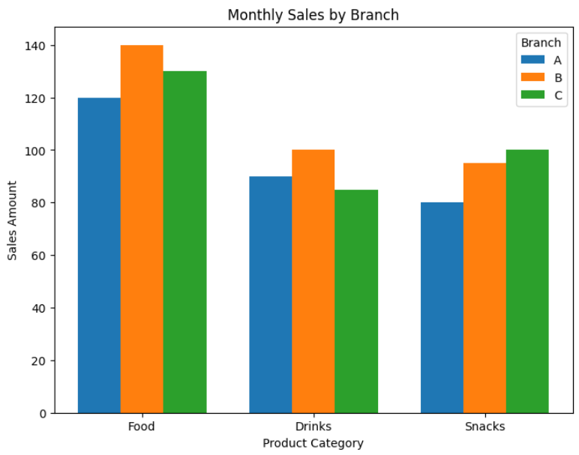

Scenario 6: Employee Salary Distribution
R program:
library(ggplot2)

set.seed(100)
employee <- data.frame(
EmployeeID=1:100,
Salary=rnorm(100,50000,10000),
Experience=sample(1:20,100,replace=TRUE),
Department=sample(c("IT","HR","Sales"),100,replace=TRUE)
)
ggplot(employee,
aes(x=Salary)) +
geom_histogram(binwidth=5000,
fill="skyblue",
color="black") +
labs(title="Salary Distribution",
x="Salary",
y="Frequency") +
theme_minimal()
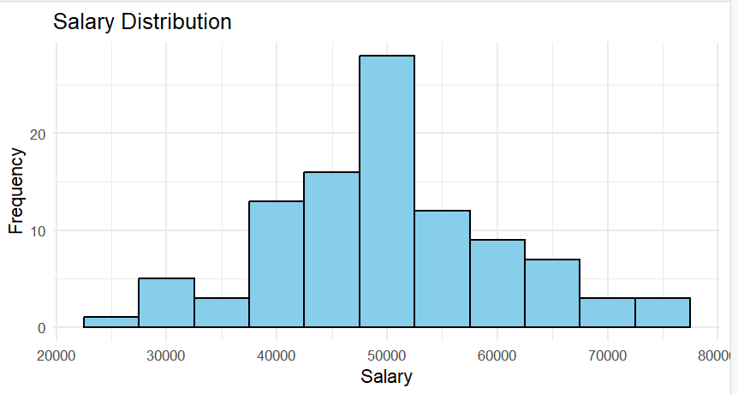
Python Program:
import pandas as pd
import numpy as np
import matplotlib.pyplot as plt

np.random.seed(100)

employee = pd.DataFrame({
"EmployeeID":range(1,101),
"Salary":np.random.normal(50000,10000,100),
"Experience":np.random.randint(1,21,100),
"Department":np.random.choice(["IT","HR","Sales"],100)
})

plt.figure(figsize=(8,6))

plt.hist(employee["Salary"],
bins=10,
color="skyblue",
edgecolor="black")

plt.title("Employee Salary Distribution")
plt.xlabel("Salary")
plt.ylabel("Frequency")
plt.show()
